**2018 PEW RESEARCH CENTER’S AMERICAN TRENDS PANEL**

**WAVE 32 FEBRUARY 2018**

**FEBRUARY 26-MARCH 11, 2018[1]**

Base: ASK ALL

*Scripter: Reverse response order for random half of sample (1-4 or 4-1). Record order. Show question text in same order as response list.*

***Scripter: Randomize and record items a-e. Show items a-e on the same screen.***

**SATLIFE [S]**

Please tell us whether you are **[show in same order as response list:**satisfied or dissatisfied**/**dissatisfied or satisfied**]** with the following aspects of your life.

a. Your family life

1 Very satisfied

2 Somewhat satisfied

3 Somewhat dissatisfied

4 Very dissatisfied

b. Your social life

1 Very satisfied

2 Somewhat satisfied

3 Somewhat dissatisfied

4 Very dissatisfied

c. Your personal financial situation

1 Very satisfied

2 Somewhat satisfied

3 Somewhat dissatisfied

4 Very dissatisfied

d. **ASK IF EMPLOYED (F_E3_FINAL=1,2 or PPWORK=1,2):**Your current job or career

1 Very satisfied

2 Somewhat satisfied

3 Somewhat dissatisfied

4 Very dissatisfied

e. The quality of life in your local community

1 Very satisfied

2 Somewhat satisfied

3 Somewhat dissatisfied

4 Very dissatisfied

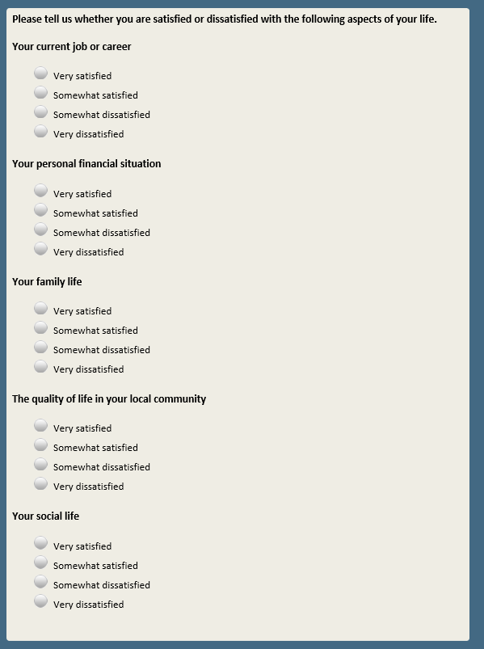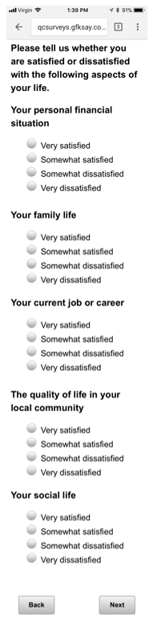

**Create Data Only Variable SOCASSIGN [S]**

**RANDOMLY ASSIGN RESPONDENTS TO A VALUE OF SOCASSIGN=1-5**

**SOCASSIGN=1 (Saw SOCTRUST)**

**SOCASSIGN=2 (Saw SOCTRUST2)**

**SOCASSIGN=3 (Saw SOCTRUST3)**

**SOCASSIGN=4 (Saw SOCTRUST4)**

**SOCASSIGN=5 (Saw SOCTRUST5)**

Base: ASK IF SOCCASSIGN=1

**SOCTRUST [S]**

Generally speaking, would you say that…   
  
1 Most people can be trusted   
2 You can’t be too careful in dealing with people

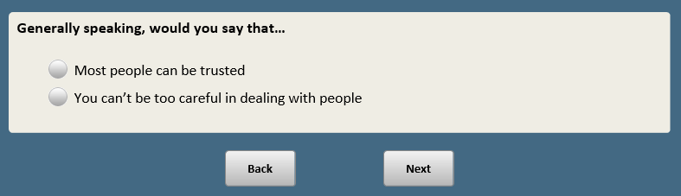

Base: ASK IF SOCASSIGN=2

*Scripter: Randomize and record response order*

**SOCTRUST2 [S]**

Generally speaking, would you say that…   
  
1 Most people can be trusted   
2 Most people cannot be trusted

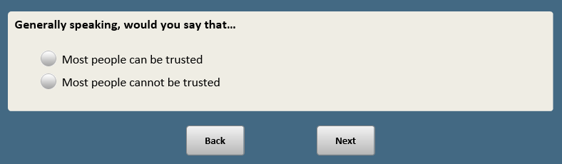

Base: ASK IF SOCASSIGN=3

*Scripter: Reverse response order for random half of sample (10-0 or 0-10). Record order. Show question text in same order as response list.*

**SOCTRUST3 [S]**

Think of a scale from 0 to 10 where **[show in same order as response list:**10 means you think most people can be trusted completely and 0 means you think most people cannot be trusted at all**/**0 means you think most people can’t be trusted at all and 10 means you think most people can be trusted completely**]**. Where would you place yourself?

On a scale of 0 to 10, I think most people…

10 (10) Can be trusted completely

9 (9)

8 (8)

7 (7)

6 (6)

5 (5)

4 (4)

3 (3)

2 (2)

1 (1)

0 (0) Can’t be trusted at all

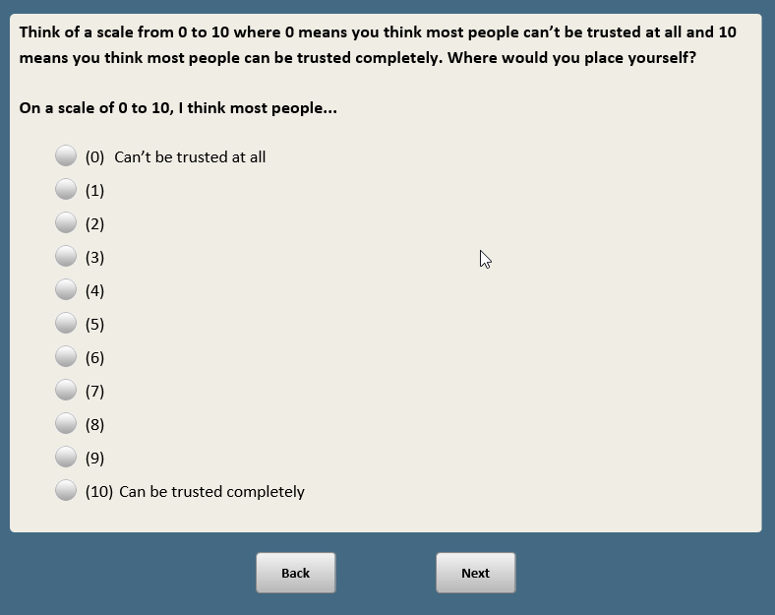

Base: ASK IF SOCASSIGN=4

**SOCTRUST4 [S]**

Generally speaking, would you say you can trust most people…

1 A great deal

2 A fair amount

3 Not too much

4 Not at all

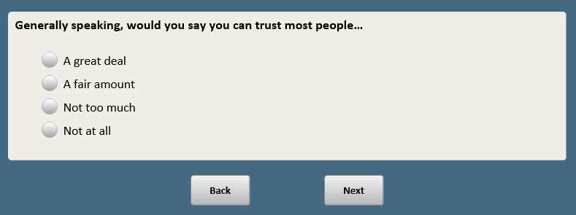

Base: ASK IF SOCASSIGN=5

*Scripter: Randomize and record response order*

**SOCTRUST5 [S]**

Generally speaking, would you say that…   
  
1 Most people can be trusted to do the right thing  
2 Most people cannot be trusted to do the right thing

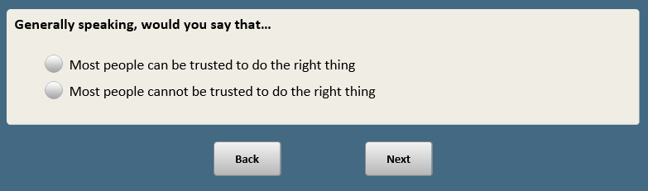

Base: ASK ALL

**COMMYRS [S]**

About how many years have you lived in your local community?

1 Less than 1 year

2 1-5 years

3 6-10 years

4 11-20 years

5 More than 20 years

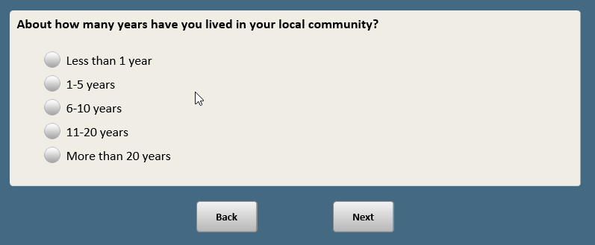

Base: ASK ALL

**COMATTACH [S]**

In general, how attached do you feel to your local community?

1 Very attached

2 Somewhat attached

3 Not too attached

4 Not at all attached

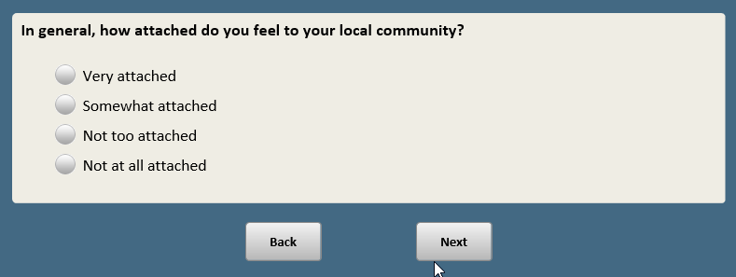

Base: ASK ALL

*Scripter: Randomize and record items a-d. Show items a-d on the same screen.*

**FEEL [S]**

The next questions are about how you feel about different aspects of your life. How often, if ever, do you feel…

a. Lonely or isolated from those around you

1 All or most of the time

2 Sometimes

3 Hardly ever

4 Never

b. You have people you can turn to for support

1 All or most of the time

2 Sometimes

3 Hardly ever

4 Never

c. Optimistic about your life

1 All or most of the time

2 Sometimes

3 Hardly ever

4 Never

d. You are too busy to enjoy life

1 All or most of the time

2 Sometimes

3 Hardly ever

4 Never

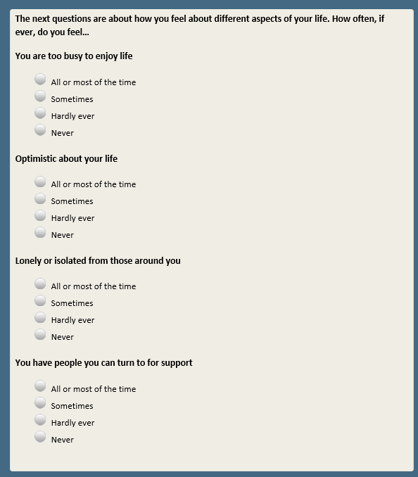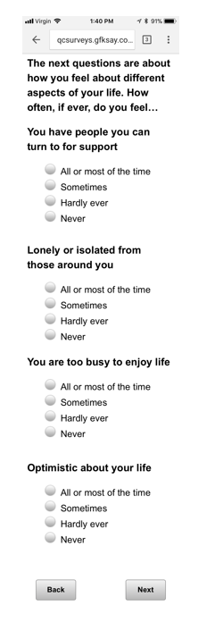

Base: ASK ALL

**INC [S]**

Do you currently have enough income to lead the kind of life you want?

1 Yes

2 No

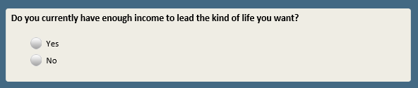

Base: INC=2 (ASK IF NO)

**INCFUTURE [S]**

Do you think you will have enough income in the future to lead the kind of life you want?

1 Yes

2 No

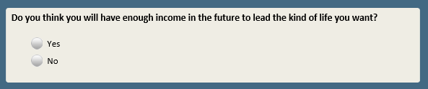

Base: ASK ALL

*Scripter: Randomize and record order of items a-h.*

*Scripter: Show on two screens.*

**COMMIMP [S]**

Regardless of whether each of the following is available where you currently live…

How important is it to you, personally, to live in a community…

a. With access to art, music and theater

1 Very important

2 Somewhat important

3 Not too important

4 Not at all important

b. That is a good place to raise children

1 Very important

2 Somewhat important

3 Not too important

4 Not at all important

c. That is racially and ethnically diverse

1 Very important

2 Somewhat important

3 Not too important

4 Not at all important

d. Where most people share your political views

1 Very important

2 Somewhat important

3 Not too important

4 Not at all important

e. With access to recreational and outdoor activities

1 Very important

2 Somewhat important

3 Not too important

4 Not at all important

f. Where you have family nearby

1 Very important

2 Somewhat important

3 Not too important

4 Not at all important

g. With a strong sense of community

1 Very important

2 Somewhat important

3 Not too important

4 Not at all important

h. Where most people share your religious views

1 Very important

2 Somewhat important

3 Not too important

4 Not at all important

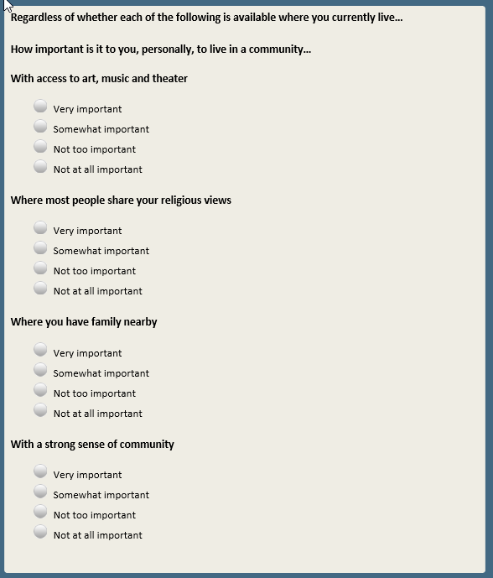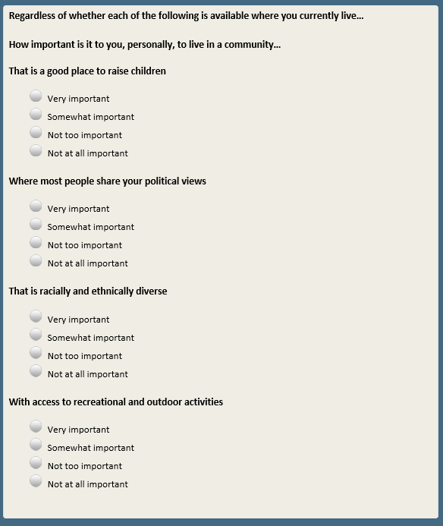

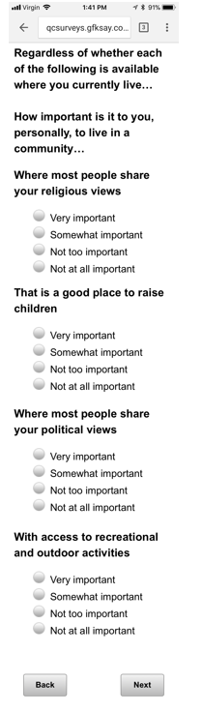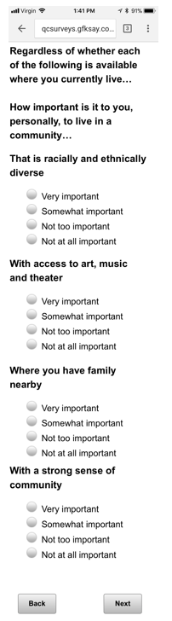

Base: ASK ALL

**FAMNEAR [S]**

Thinking about members of your extended family who don’t live with you, about how many of them live within an hour’s drive of where you live now?

By extended family, we mean children, parents, grandparents, grandchildren, brothers, sisters, cousins, aunts, uncles and in-laws.

1 All or most

2 Some

3 Only a few

4 None

**[SPACE]**

5 I don’t have extended family

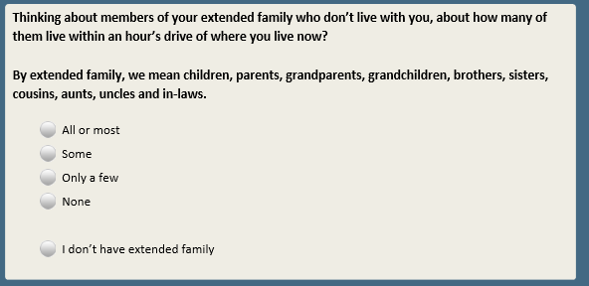

Base: ASK ALL

*Scripter: Randomize and record order of items a-d. Show a-d on the same screen.*

**SUCCESSIMP [S]**

How important, if at all, do you think each of the following is in helping a young person succeed in the world today?

a. A college education

1 Essential

2 Important but not essential

3 Not important

b. Knowing how to get along with people

1 Essential

2 Important but not essential

3 Not important

c. A good work ethic

1 Essential

2 Important but not essential

3 Not important

d. Work skills learned on the job

1 Essential

2 Important but not essential

3 Not important

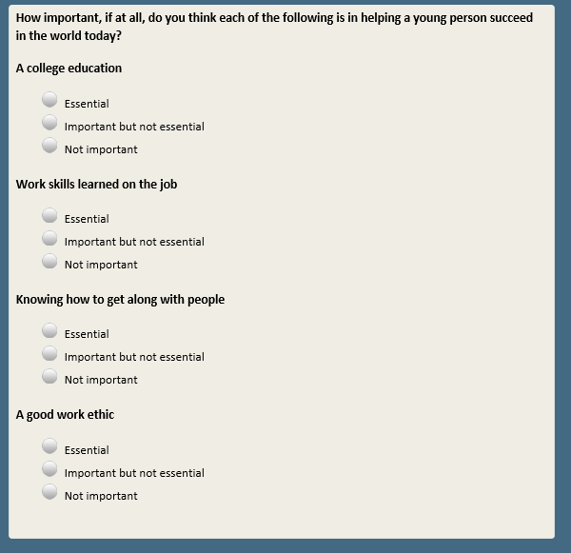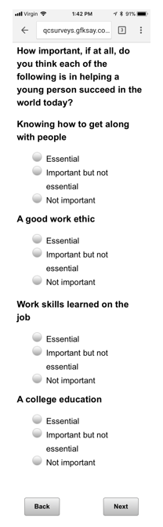

Scripter: Randomize and record order of FEDSHAREa-FEDSHAREc. Show on same screen.

Base: ASK ALL

*Scripter: Randomize and record response order 1 and 2. Always keep 3 last.*

**FEDSHAREa [S]**

Thinking about how the federal government spends money, do you think URBAN areas get…

1 More than their fair share

2 Less than their fair share

3 About the right amount

Base: ASK ALL

*Scripter: Show response options in same order as FEDSHAREa.*

**FEDSHAREb [S]**

Thinking about how the federal government spends money, do you think SUBURBAN areas get…

1 More than their fair share

2 Less than their fair share

3 About the right amount

Base: ASK ALL

*Scripter: Show response options in same order as FEDSHAREa.*

**FEDSHAREc [S]**

Thinking about how the federal government spends money, do you think RURAL areas get…

1 More than their fair share

2 Less than their fair share

3 About the right amount

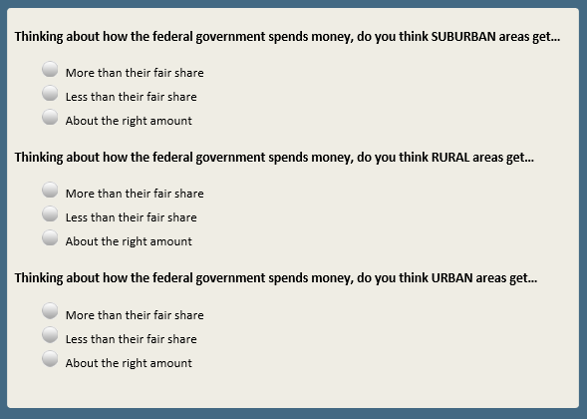

Base: ASK ALL

*Scripter: Randomize and record order of items a-m.*

*Scripter: Split onto two screens.*

**LOCALPROB [S]**

Regardless of whether you think each of the following is a problem in our country…

How much, if at all, is each of the following a problem in YOUR LOCAL COMMUNITY?

a. Availability of jobs

1 Major problem in my local community

2 Minor problem in my local community

3 Not a problem in my local community

b. Drug addiction

1 Major problem in my local community

2 Minor problem in my local community

3 Not a problem in my local community

c. Access to grocery stores

1 Major problem in my local community

2 Minor problem in my local community

3 Not a problem in my local community

d. Access to good doctors and hospitals

1 Major problem in my local community

2 Minor problem in my local community

3 Not a problem in my local community

e. Access to high-speed internet

1 Major problem in my local community

2 Minor problem in my local community

3 Not a problem in my local community

f. Access to public transportation

1 Major problem in my local community

2 Minor problem in my local community

3 Not a problem in my local community

g. Racism

1 Major problem in my local community

2 Minor problem in my local community

3 Not a problem in my local community

h. Availability of affordable housing

1 Major problem in my local community

2 Minor problem in my local community

3 Not a problem in my local community

i. Poverty

1 Major problem in my local community

2 Minor problem in my local community

3 Not a problem in my local community

j. Crime

1 Major problem in my local community

2 Minor problem in my local community

3 Not a problem in my local community

k. The quality of K-12 education in the public schools

1 Major problem in my local community

2 Minor problem in my local community

3 Not a problem in my local community

l.F1 **[if xform=1]** The condition of roads, bridges and other infrastructure

1 Major problem in my local community

2 Minor problem in my local community

3 Not a problem in my local community

m.F2 **[if xform=2]** Traffic

1 Major problem in my local community

2 Minor problem in my local community

3 Not a problem in my local community

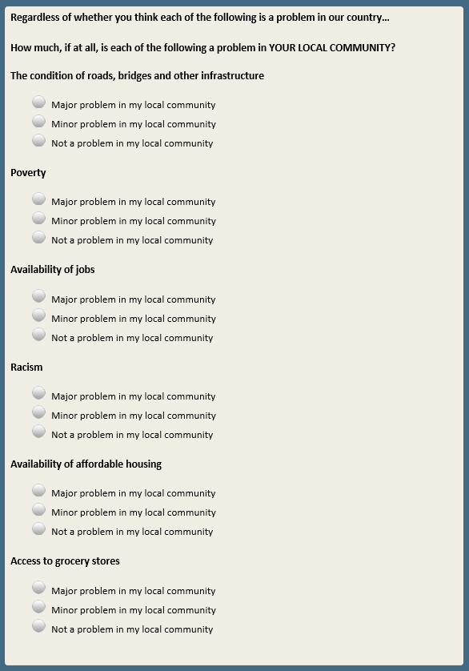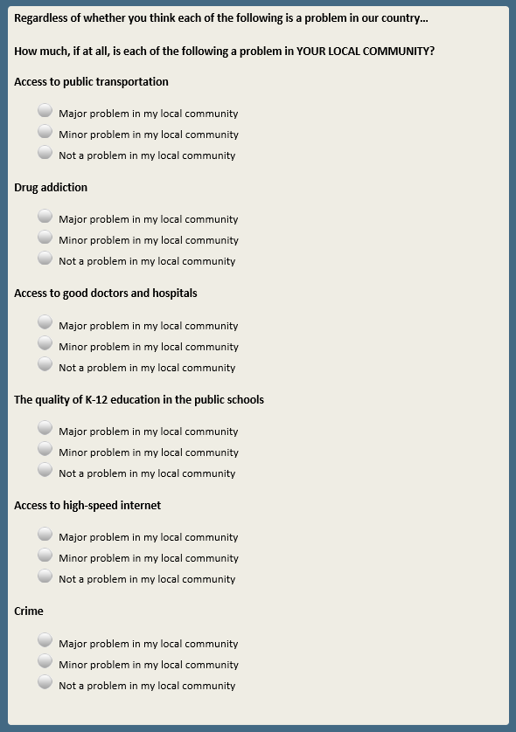

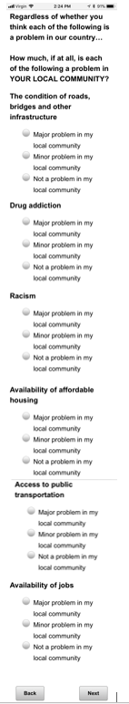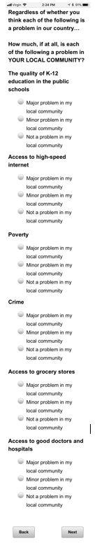

Base: ASK ALL

*Scripter: Randomize and record response order 1 and 2. Always keep 3 last.*

**JOBSFUTURE [S]**

Looking ahead 10 years, do you expect the availability of jobs where you live to…

1 Get better

2 Get worse

3 Stay about the same

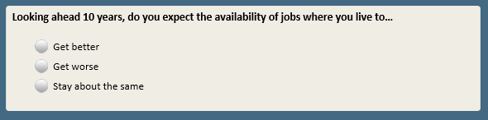

Base: ASK ALL

*Scripter: Randomize and record item order a-d. Show a-d on the same screen.*

**HARASS1 [S]**

On a different subject…

When it comes to sexual harassment and sexual assault in the workplace today, how much of a problem, if at all, would you say each of the following is?

a. Women claiming they have experienced sexual harassment or assault when it hasn’t actually occurred

1 Major problem

2 Minor problem

3 Not a problem

b. Employers firing men who have been accused of sexual harassment or assault before finding out all the facts

1 Major problem

2 Minor problem

3 Not a problem

c. Men getting away with committing sexual harassment or assault

1 Major problem

2 Minor problem

3 Not a problem

d. Women not being believed when they claim that they have experienced sexual harassment or assault

1 Major problem

2 Minor problem

3 Not a problem

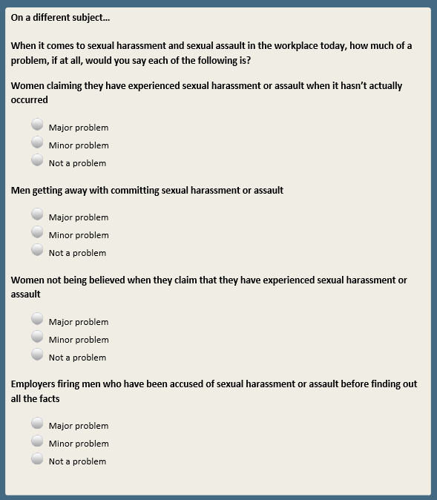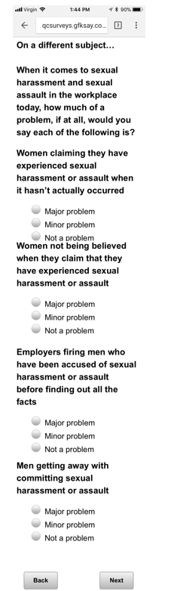

Base: XFORM=1

*Scripter: Randomize and record response order 1 and 2. Always keep 3 last.*

**HARASS2F1 [S]**

In the long run, do you think the increased focus on sexual harassment and assault will lead to…

1 More opportunities for women in the workplace

2 Fewer opportunities for women in the workplace

3 Won’t make much of a difference

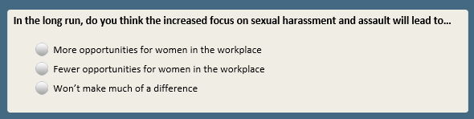

Base: XFORM=2

*Scripter: Randomize and record response order 1 and 2. Always keep 3 last.*

*Scripter: Show question text in same order as response list.*

**HARASS3F2 [S]**

Do you think the increased focus on sexual harassment and assault has made it **[show in same order as response list:**easier or harder**/**harder or easier**]** for men to know how to interact with women in the workplace, or hasn’t it made much difference?

1 Has made it easier for men

2 Has made it harder for men

3 Hasn’t made much difference

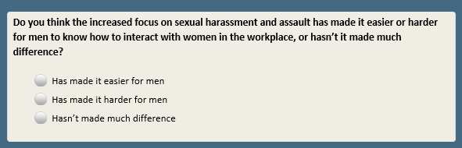

Base: ASK ALL

**HARASS4 [S]**

Now thinking about your own experiences…

Have you ever personally received unwanted sexual advances or verbal or physical harassment of a sexual nature? This can be in any circumstance, whether or not work-related.

1 Yes

2 No

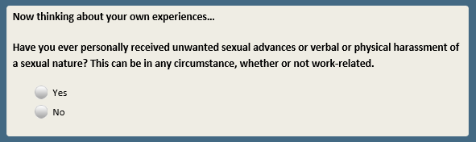

Base: HARASS4=1 (ASK IF HAS RECEIVED UNWANTED SEXUAL ADVANCES)

**HARASS5 [S]**

Have you received unwanted sexual advances or verbal or physical harassment of a sexual nature…

1 In a professional or work setting

2 Outside of a professional or work setting

3 Both

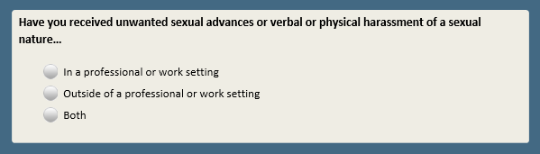

Base: ASK ALL

**GROWUPNEAR [S]**

Now thinking again about the community where you live…

Do you currently live in or near the community where you grew up?

1 Yes

2 No

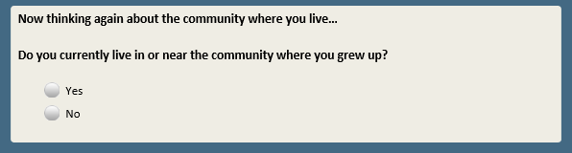

Base: GROWUPNEAR=1 (ASK IF R LIVES IN COMMUNITY WHERE THEY GREW UP)

**LIFELOC [S]**

And have you lived in or near this community your entire life, or have you lived in other places?

1 Lived in or near this community my entire life

2 Lived in other places

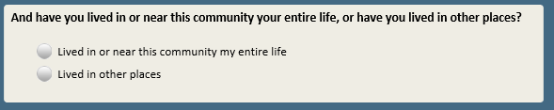

Base: LIFELOC=1 (ASK IF R HAS ALWAYS LIVED IN THEIR COMMUNITY)

*Scripter: Allow respondent to enter as much text as they would like without character limit*

**REASSTAY [O]**

What are the main reasons you have stayed in or near the community where you grew up?

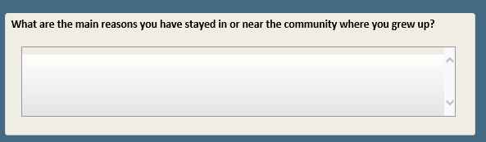

Base: LIFELOC=2 (ASK IF R HAS LIVED ELSEWHERE BUT CURRENTLY LIVES IN COMMUNITY WHERE THEY GREW UP)

*Scripter: Allow respondent to enter as much text as they would like without character limit*

**REASBACK [O]**

What are the main reasons you came back to live in or near the community where you grew up?

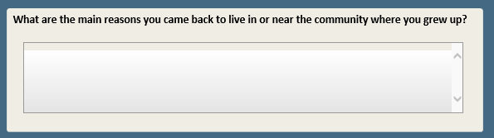

Base: GROWUPNEAR=2 (ASK IF R DOES NOT CURRENTLY LIVE IN COMMUNITY WHERE THEY GREW UP)

*Scripter: Allow respondent to enter as much text as they would like without character limit*

**REASMOVE [O]**

What are the main reasons you do not live in or near the community where you grew up?

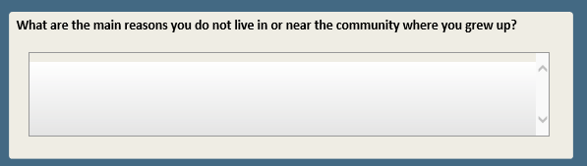

Randomize and record order of VALUEURBAN-VALUERURAL. Show on same screen.

Base: ASK ALL

*Scripter: Reverse response order for random half of sample (1-4 or 4-1). Record order.*

**VALUEURBAN [S]**

**[Show before first question:** Now thinking about people who live in different types of communities…**]**

In general, do you think most people who live in URBAN areas have values that are…

1 Very similar to your values

2 Somewhat similar to your values

3 Somewhat different from your values

4 Very different from your values

Base: ASK ALL

*Scripter: Show response list in same order as VALUEURBAN*

**VALUESUBURB [S]**

In general, do you think most people who live in SUBURBAN areas have values that are…

1 Very similar to your values

2 Somewhat similar to your values

3 Somewhat different from your values

4 Very different from your values

Base: ASK ALL

*Scripter: Show response list in same order as VALUEURBAN*

**VALUERURAL [S]**

In general, do you think most people who live in RURAL areas have values that are…

1 Very similar to your values

2 Somewhat similar to your values

3 Somewhat different from your values

4 Very different from your values

**~~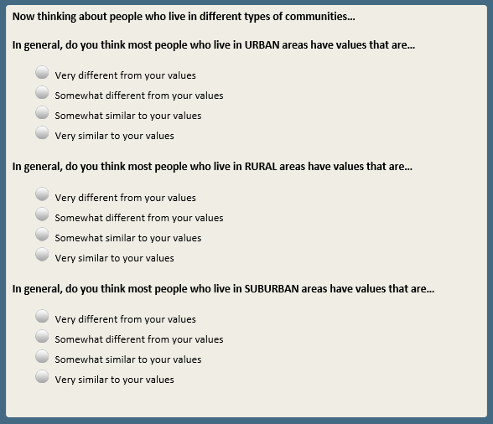~~**

Base: ASK ALL

**NEIGHKNOW [S]**

Thinking of your neighbors, would you say you…

1 Know all of them

2 Know most of them

3 Know only some of them

4 Don’t know any of them

**~~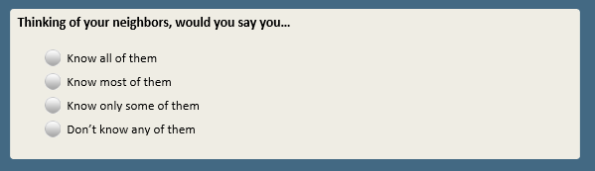~~**

Base: NEIGHKNOW=1-3 (ASK IF KNOW AT LEAST SOME OF THEIR NEIGHBORS)

*Scripter: Randomize and record order of items a-d. Show a-d on same screen.*

**NEIGHINTER [S]**

In general, how often, if ever, would you say you…

a. Have face-to-face conversations with any of your neighbors

1 Every day

2 Several times a week

3 About once a week

4 About once a month

5 Less than once a month

6 Never

b. Talk on the phone with any of your neighbors

1 Every day

2 Several times a week

3 About once a week

4 About once a month

5 Less than once a month

6 Never

c. Exchange emails or text messages with any of your neighbors

1 Every day

2 Several times a week

3 About once a week

4 About once a month

5 Less than once a month

6 Never

d. Have parties or get-togethers with any of your neighbors

1 Every day

2 Several times a week

3 About once a week

4 About once a month

5 Less than once a month

6 Never

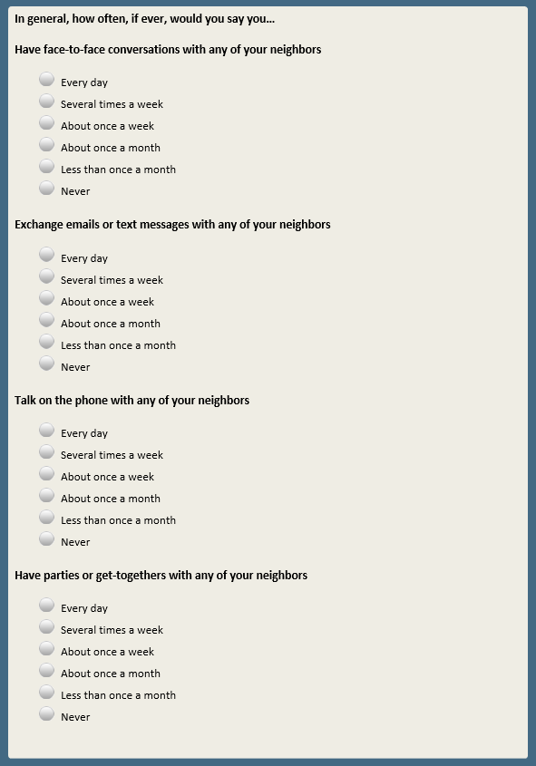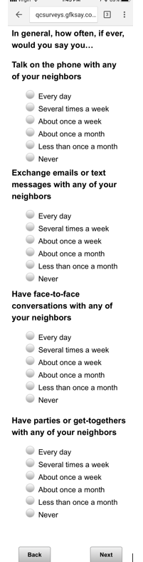

Base: NEIGHKNOW=1-3 (ASK IF KNOW AT LEAST SOME OF THEIR NEIGHBORS)

**NEIGHKEYS [S]**

Do you have any neighbors you would feel comfortable asking to keep a set of keys to your home for emergencies (for example if you were locked out)?

1 Yes

2 No

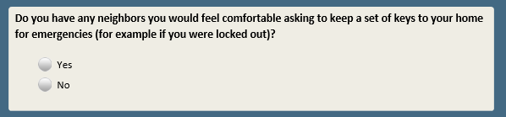

Base: NEIGHKNOW=1-3 (ASK IF KNOW AT LEAST SOME OF THEIR NEIGHBORS)

**NEIGHKIDS [S]**

Do you have any neighbors you would feel comfortable asking to watch your children for half an hour in a pinch?

1 Yes

2 No

**[SPACE]**

8 Does not apply

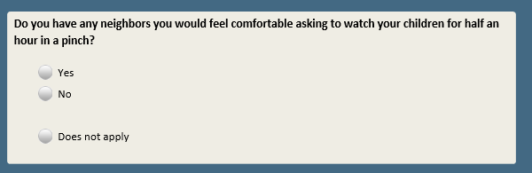

Base: ASK ALL

*Scripter: Randomize and record order of items a-c. Show a-c on same screen.*

**NEIGHSAME [S]**

As far as you know, how many of your neighbors…

a. Are the same race or ethnicity as you

1 All of them

2 Most of them

3 About half

4 Only some of them

5 None of them

b. Are the same social class as you

1 All of them

2 Most of them

3 About half

4 Only some of them

5 None of them

c. Have the same political views as you

1 All of them

2 Most of them

3 About half

4 Only some of them

5 None of them

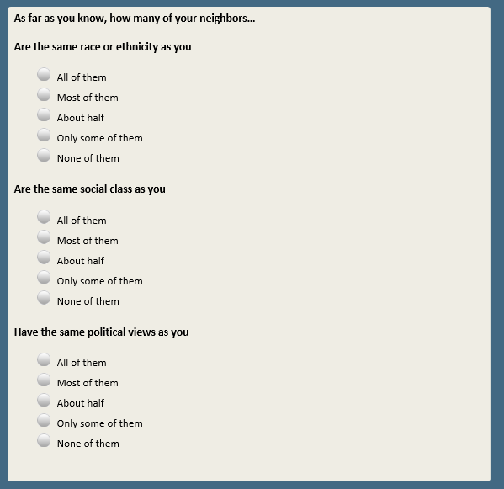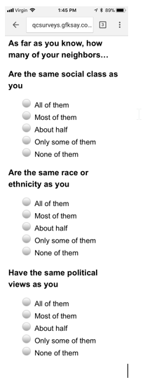

Base: ASK ALL

**IMMCOMM [S]**

As far as you know, how many immigrants, if any, would you say there are in your local community?

1 Many

2 Some

3 Only a few

4 None

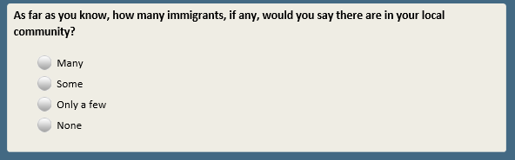

Base: IMMCOMM=1-3 (ASK IF AT LEAST A FEW IMMIGRANTS IN LOCAL COMMUNITY)

*Scripter: Randomize and record response options 1 and 2. Always keep 3 last.*

**IMMIMPACT [S]**

Thinking about the immigrants who live in your local community, in general, would you say their impact on the community has been…

1 Mostly positive

2 Mostly negative

3 Neither positive nor negative

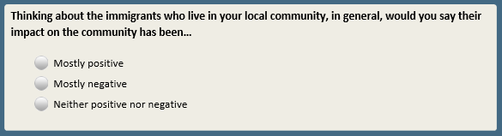

Base: ASK ALL

*Scripter: Reverse response order for random half of sample (1-3 or 3-1). Record order.*

**GROWUPUSR [S]**

How would you describe the community where you spent the majority of time when you were growing up?

1 Urban

2 Suburban

3 Rural

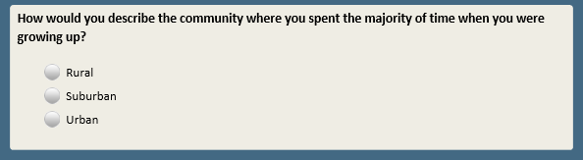

Base: ASK ALL

*Scripter: Show responses in same order as GROWUPUSR*

**COMTYPE2 [S]**

How would you describe the community where you currently live?

1 Urban

2 Suburban

3 Rural

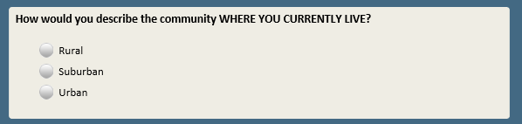

Base: COMTYPE2=1 (ASK IF LIVES IN AN URBAN AREA)

**CITYSIZE [S]**

Would you say you currently live in a…

1 Large city

2 Midsize city

3 Small city

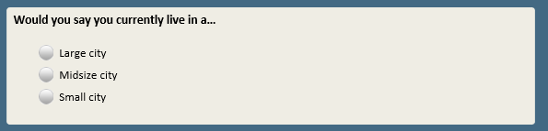

Base: COMTYPE2=2 (ASK IF LIVES IN A SUBURB)

**SUBURBNEAR [S]**

Thinking about the city your community is a suburb of, would you say you live…

1 Very close to that city

2 Somewhat close to that city

3 Not too close to that city

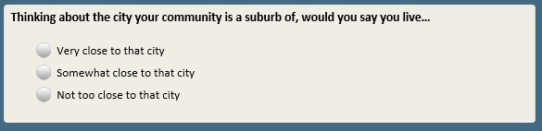

Base: COMTYPE2=1-3 (ASK IF DID NOT SKIP COMTYPE2)

*Scripter: Reverse response order for random half of sample (1-4 or 4-1). Record order. Show question text in same order as response list*

**VIEWCOMM [S]**

In general, do you think most people who DO NOT live in **[IF COMTYPE2=1:**an urban area**; IF COMTYPE2=2:**a suburban area**; IF COMTYPE2=3:**a rural area**]** have a **[show in same order as response list:**positive or negative**/**negative or positive**]** view of people who DO live in **[IF COMTYPE2=1:**urban areas**; IF COMTYPE2=2:**suburban areas**; IF COMTYPE2=3:**rural areas**]**?

1 Very positive

2 Somewhat positive

3 Somewhat negative

4 Very negative

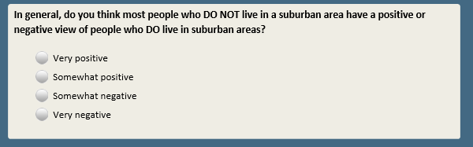

Base: COMTYPE2=1-3 (ASK IF DID NOT SKIP COMTYPE2)

**PROBSELF [S]**

How well, if at all, do you think most people who DO NOT live in **[IF COMTYPE2=1:**an urban area**; IF COMTYPE2=2:**a suburban area**; IF COMTYPE2=3:** a rural area**]** understand the types of problems faced by people who DO live in **[IF COMTYPE2=1:** urban areas**; IF COMTYPE2=2:** suburban areas**; IF COMTYPE2=3:** rural areas**]**?

1 Very well

2 Somewhat well

3 Not too well

4 Not at all well

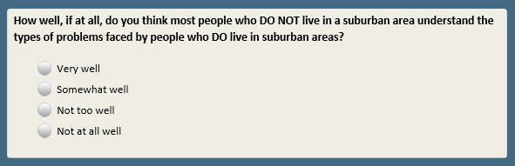

Scripter: Show PROBURBAN-PROBRURAL in same order as COMTYPE2. Show on same screen.

Base: COMTYPE2=2 or 3 (ASK IF R LIVES IN SUBURBAN OR RURAL AREA)

**PROBURBAN [S]**

How well, if at all, do you think YOU understand the types of problems faced by people who live in URBAN areas?

1 Very well

2 Somewhat well

3 Not too well

4 Not at all well

Base: COMTYPE2=1 or 3 (ASK IF R LIVES IN URBAN OR RURAL AREA)

**PROBSUBURB [S]**

How well, if at all, do you think YOU understand the types of problems faced by people who live in SUBURBAN areas?

1 Very well

2 Somewhat well

3 Not too well

4 Not at all well

Base: COMTYPE2=1 or 2 (ASK IF R LIVES IN URBAN OR SUBURBAN AREA)

**PROBRURAL [S]**

How well, if at all, do you think YOU understand the types of problems faced by people who live in RURAL areas?

1 Very well

2 Somewhat well

3 Not too well

4 Not at all well

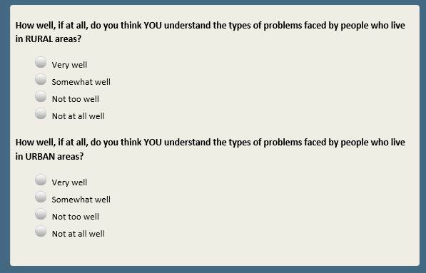

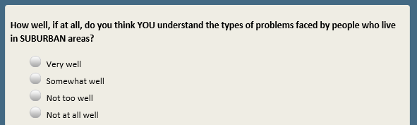

Base: ASK ALL

**WANTMOVE [S]**

If you could, would you want to move to a different community?

1 Would want to move

2 Would not want to move

3 Not sure

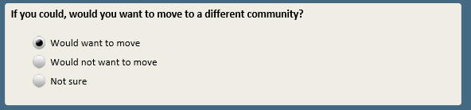

Base: ASK ALL

**WILLMOVE [S]**

Regardless of whether you would want to move, how likely is it that you WILL move to a different community at some point in the future?

1 Very likely

2 Somewhat likely

3 Not too likely

4 Not at all likely

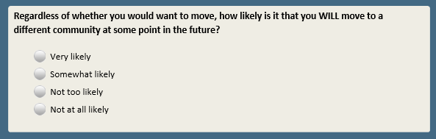

Base: WANTMOVE=1 AND COMTYPE2=1 (ASK IF WOULD WANT TO MOVE AND LIVES IN AN URBAN AREA)

**MOVEURBAN [S]**

If you could move to a different community, would you want to…

1 Stay in an urban area

2 Move to a suburban area

3 Move to a rural area

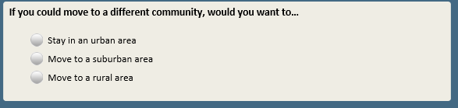

Base: WANTMOVE=1 AND COMTYPE2=2 (ASK IF WOULD WANT TO MOVE AND LIVES IN A SUBURB)

**MOVESUBURB [S]**

If you could move to a different community, would you want to…

1 Stay in a suburban area

2 Move to an urban area

3 Move to a rural area

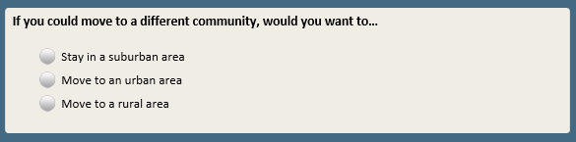

Base: WANTMOVE=1 AND COMTYPE2=3 (ASK IF WOULD WANT TO MOVE AND LIVES IN A RURAL AREA)

**MOVERURAL [S]**

If you could move to a different community, would you want to…

1 Stay in a rural area

2 Move to an urban area

3 Move to a suburban area

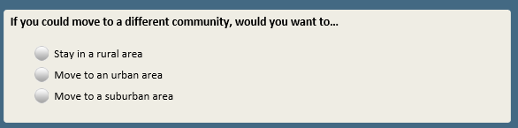

Base: ASK ALL

Scripter: Show as number boxes (do not show thermometer)

Scripter: Randomize and record order of THERMTRUMP-THERMPENCE. Show on same screen.

Add system generated instruction that reads “Enter the number in the box between 0 and 100 that reflects your feelings”

Custom prompt: “Please enter the “degree” or number between 0 and 100 that reflects your feelings in the box. If you would like to skip, click Next.”

**THERMO [Q, range 0-100]**

We'd like to get your feelings toward a number of people on a “feeling thermometer.” A rating of zero degrees means you feel as cold and negative as possible. A rating of 100 degrees means you feel as warm and positive as possible. You would rate the person at 50 degrees if you don’t feel particularly positive or negative toward them.

*[Enter the number in the box between 0 and 100 that reflects your feelings]*

**THERMTRUMP.** How do you feel toward Donald Trump? **[Q]**

**THERMBOBAMA.** How do you feel toward Barack Obama? **[Q]**

**THERMPENCE.** How do you feel toward Mike Pence? **[Q]**

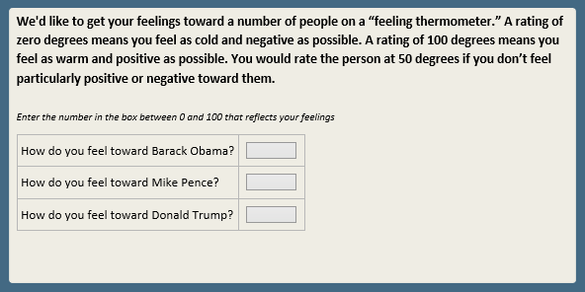

Base: ASK ALL

**ETHNCMAJ [S]**

According to the U.S. Census Bureau, in the next 25 to 30 years, African Americans, Latinos, and people of Asian descent will make up a majority of the population. In general, do you think that this is…

1 Good for the country

2 Bad for the country

3 Neither good nor bad for the country

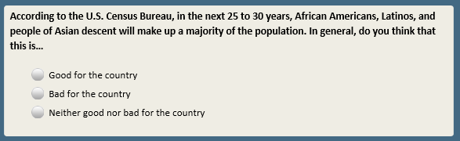

Scripter: Randomize and record order of IMMCULT2-GOVT_ROLE. Show all on same screen.

Base: ASK ALL

*Scripter: Randomize and record response order.*

**IMMCULT2 [S]**

Which statement comes closer to your own views — even if neither is exactly right?

1 The growing number of newcomers from other countries threatens traditional American customs and values

2 The growing number of newcomers from other countries strengthens American society

Base: ASK ALL

*Scripter: Randomize and record response order.*

**MARRFAM2 [S]**

Which statement comes closer to your own views — even if neither is exactly right?

1 Society is better off if people make marriage and having children a priority

2 Society is just as well off if people have priorities other than marriage and children

Base: ASK ALL

*Scripter: Randomize and record response order.*

**ECONFAIR2 [S]**

Which statement comes closer to your own views — even if neither is exactly right?

1 The economic system in this country unfairly favors powerful interests

2 The economic system in this country is generally fair to most Americans

Base: ASK ALL

*Scripter: Randomize and record response order.*

**WOMENOPPS [S]**

Which statement comes closer to your own views — even if neither is exactly right?

1 The obstacles that once made it harder for women than men to get ahead are now largely gone

2 There are still significant obstacles that make it harder for women to get ahead than men

Base: ASK ALL

*Scripter: Randomize and record response order.*

**GOVT_ROLE [S]**

Which statement comes closer to your own views – even if neither is exactly right?

1 Government should do more to solve problems

2 Government is doing too many things better left to businesses and individuals

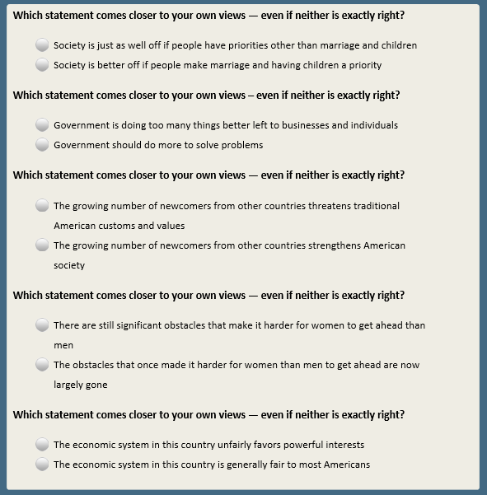

Base: ASK ALL

**WHADVANT [S]**

On a different subject…

How much, if at all, do white people benefit from advantages in society that black people do not have?

1 A great deal

2 A fair amount

3 Not too much

4 Not at all

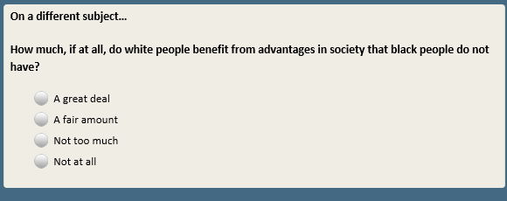

Base: ASK ALL

*Scripter: Reverse response order for random half of sample (1-4 or 4-1). Record order. Show question text in same order as response list*

**GAYMARR2 [S]**

As you may know, same-sex marriage is now legal in the U.S. Do you think this is **[show in same order as response list:**a good thing or a bad thing**/**a bad thing or a good thing**]** for our society?

1 Very good thing

2 Somewhat good thing

3 Somewhat bad thing

4 Very bad thing

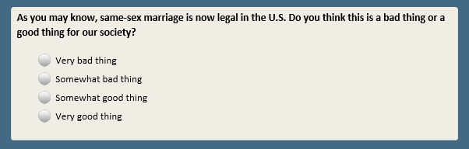

Base: ASK ALL

*Scripter: Randomize and record response order.*

**ABORTION [S]**

Do you think abortion should be…

1 LEGAL in all or most cases

2 ILLEGAL in all or most cases

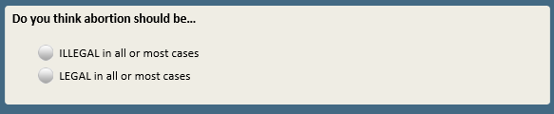

Base: ABORTION=1 (ASK IF LEGAL IN ALL/MOST CASES)

**ABORTIONRESTR [S]**

Which statement comes closer to your own views — even if neither is exactly right?

1 There are some situations in which abortion should be restricted

2 There are no situations at all where abortion should be restricted

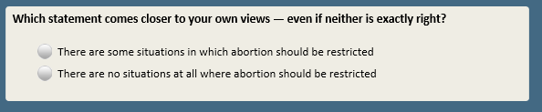

Base: ABORTION=2 (ASK IF ILLEGAL IN ALL/MOST CASES)

**ABORTIONALLOW [S]**

Which statement comes closer to your own views — even if neither is exactly right?

1 There are some situations in which abortion should be allowed

2 There are no situations at all where abortion should be allowed

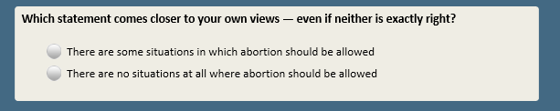

Base: ASK ALL

*Scripter: Reverse response order for random half of sample (1-5 or 5-1) and record order*

**CLASS [S]**

If you were asked to use one of these commonly used names for the social classes, which would you say you belong in?

1 Upper class

2 Upper-middle class

3 Middle class

4 Lower-middle class

5 Lower class

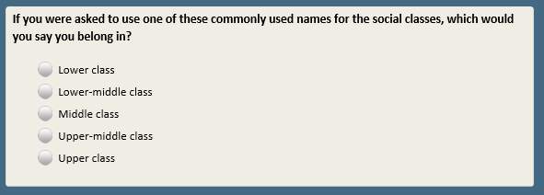

Base: XFORM=1 (ATP SAMPLE ONLY)

*Scripter: Randomize and record response order.*

**MISINFG [S]**

Thinking about news and information online, including social media…

Which comes closer to your own view – even if neither is exactly right?

1 The U.S. government should take steps to restrict false information online, even if it limits people from freely publishing or accessing information

2 People’s freedom to publish and access information should be protected, even if it means false information can also be published

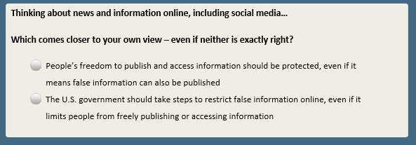

Base: XFORM=2 (ATP SAMPLE ONLY)

*Scripter: Randomize and record response order.*

**MISINFT [S]**

Thinking about news and information online, including social media…

Which comes closer to your own view – even if neither is exactly right?

1 Technology companies should take steps to restrict false information online, even if it limits people from freely publishing or accessing information

2 People’s freedom to publish and access information should be protected, even if it means false information can also be published

**~~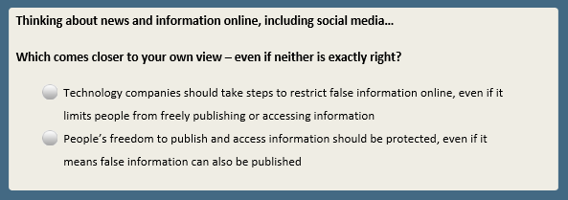~~**

1. Open-end responses are excluded from public datasets to protect the confidentiality of ATP panelists